

**DATA FLOW DIAGRAM LEVEL 0:**

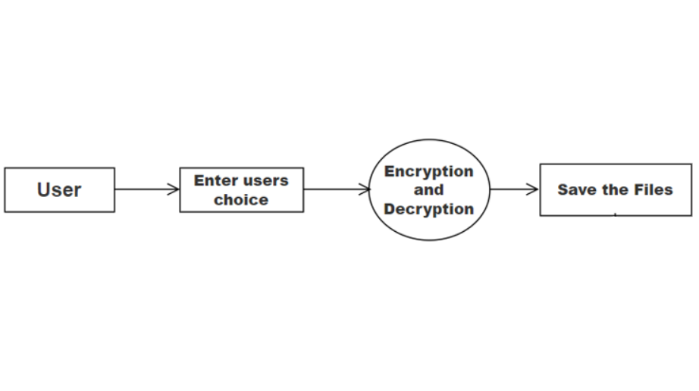

**DATA FLOW DIAGRAM LEVEL 1:**

S